Notes from Aida meeting on 9th October 2008

Patrick gave the electronics presentation.
On his second slide he showed the positions of the bolt holes he proposed
Doesn’t know if they’re suitable for mechanical rigidity.

It is necessary to encapsulate the Asics
The material used to encapsulate the Asics should be removable
It is very critical that the Asic chips aren’t damaged
This could be done using a lid to cover the Asics
The lid should be assembled using a jig

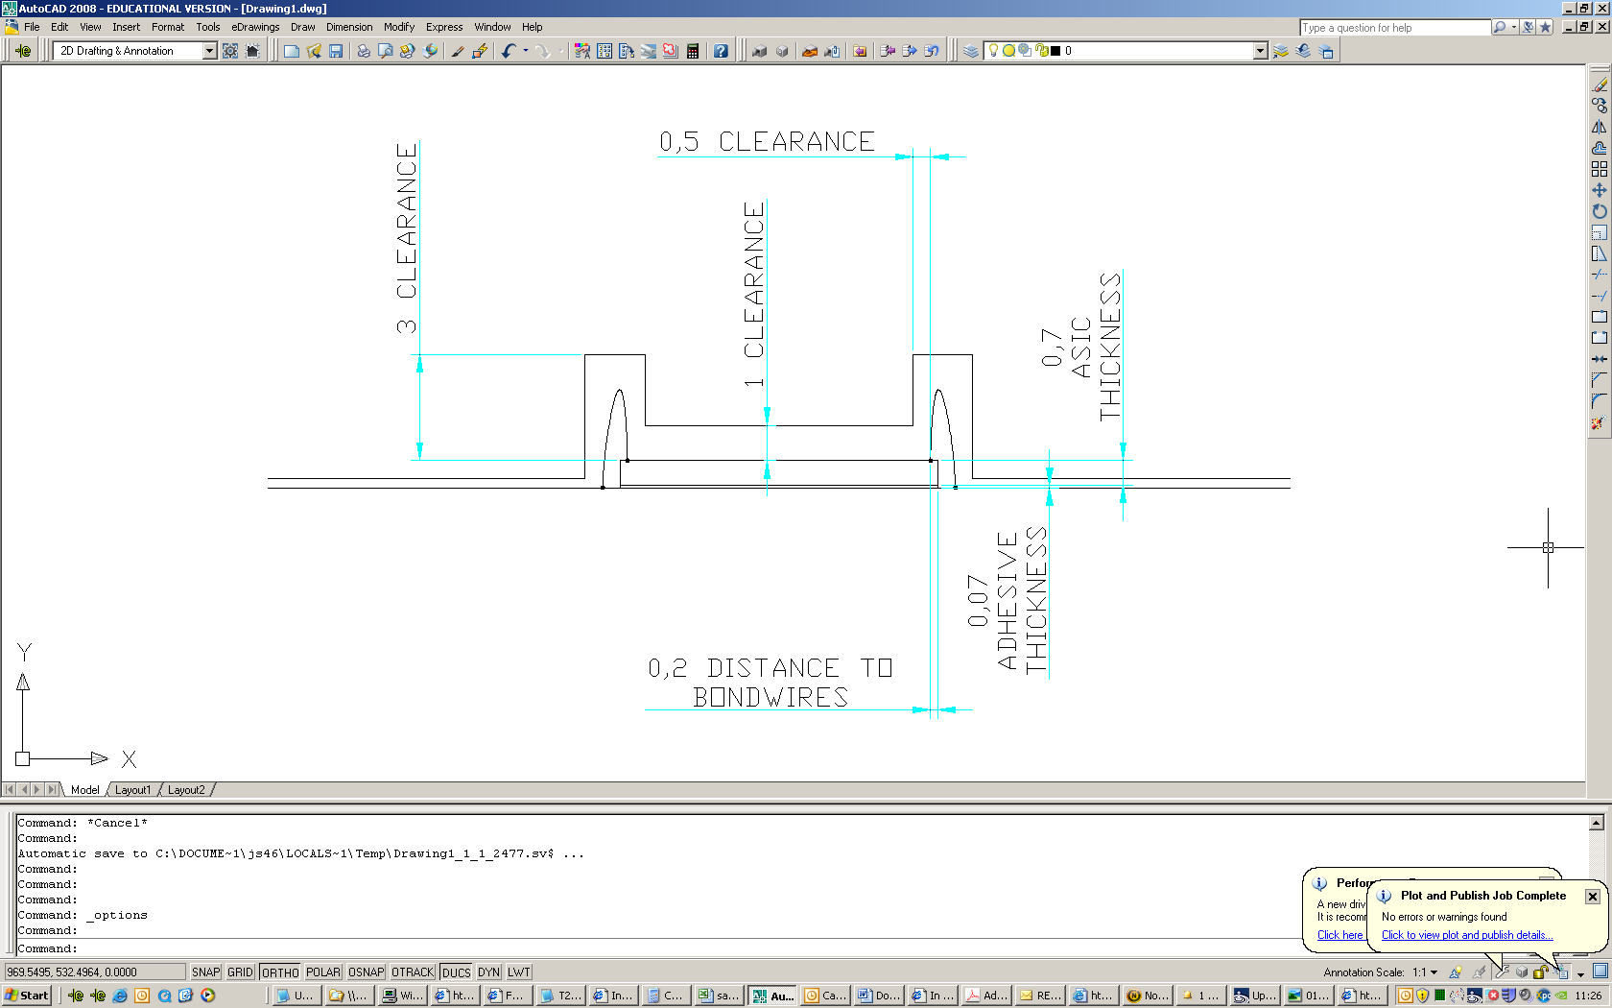

The bond wire loop height ranges from 1-2mm.
Require a clearance of 1mm on top of that.

The groove should go round the asic on all sides so that the Asic is light tight
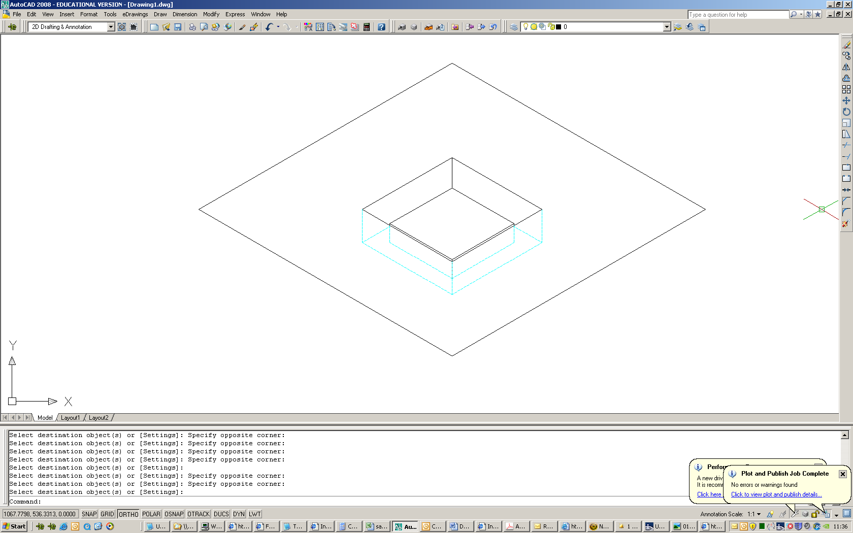

The above type of profile is expected.

The idea is to have 1 cover covering all the Asics.
The Asic is bonded using a thermal conducting epoxy, as the layer of glue is very thin, it should be ignored.

The thickness of the ground plane has not yet been decided, but the standard plating thickness is 1 ounce/square foot.

1 suggestion regarding heat removal is to run busbars underneath the board.

Maximum power output is 3.3v @ 0.5A per chip

A jig will be required for the cap.
And a press may also be required.

